**PROOF OF TESTING – MIKAELA G. SANTOS – 2ECE-A**

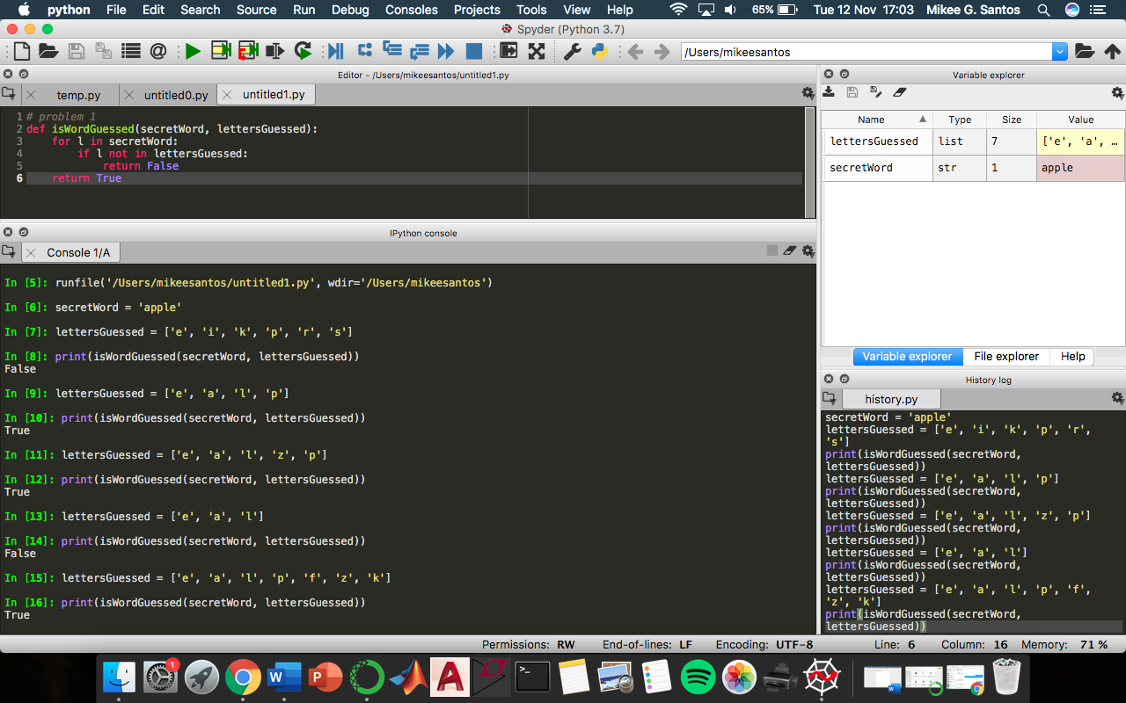

***Problem 1: isWordGuessed***

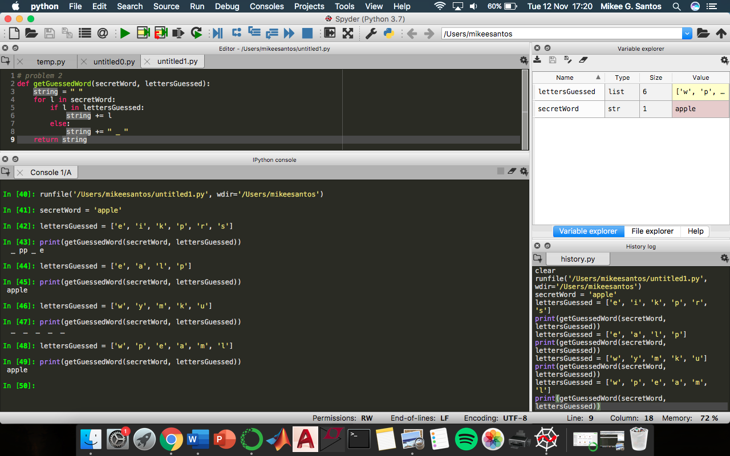

***Problem 2: getGuessedWord***

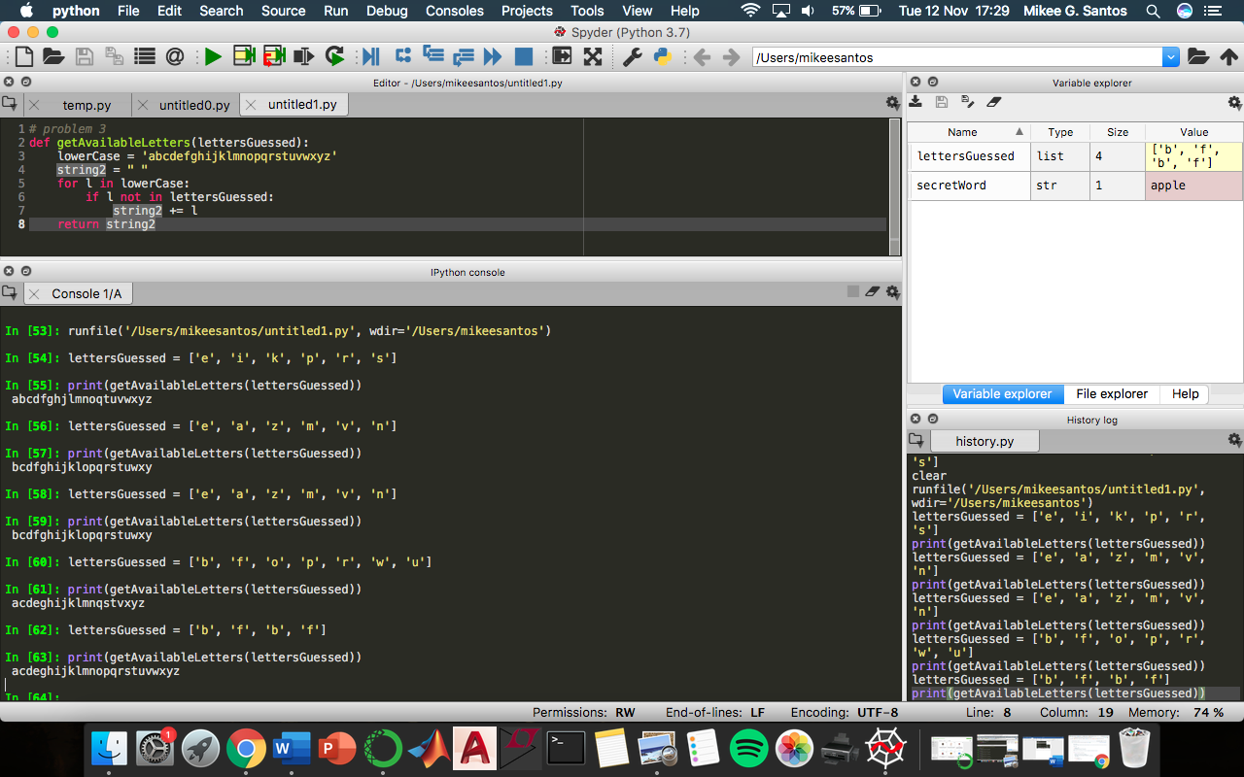

***Problem 3: getAvailableLetters***

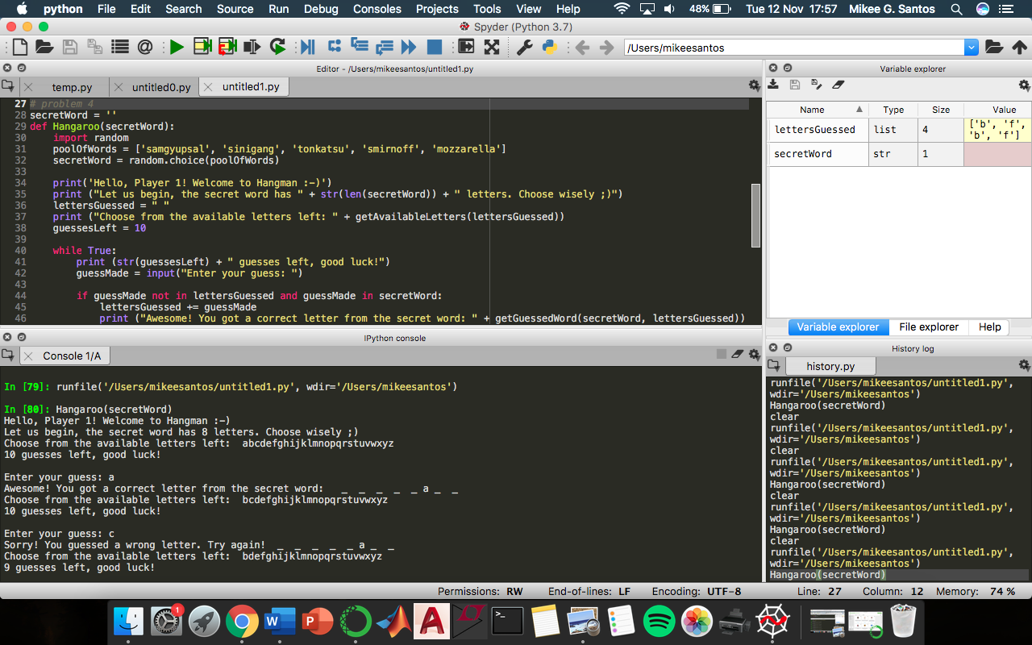

***Problem 4: Hangaroo – Winner (1)***

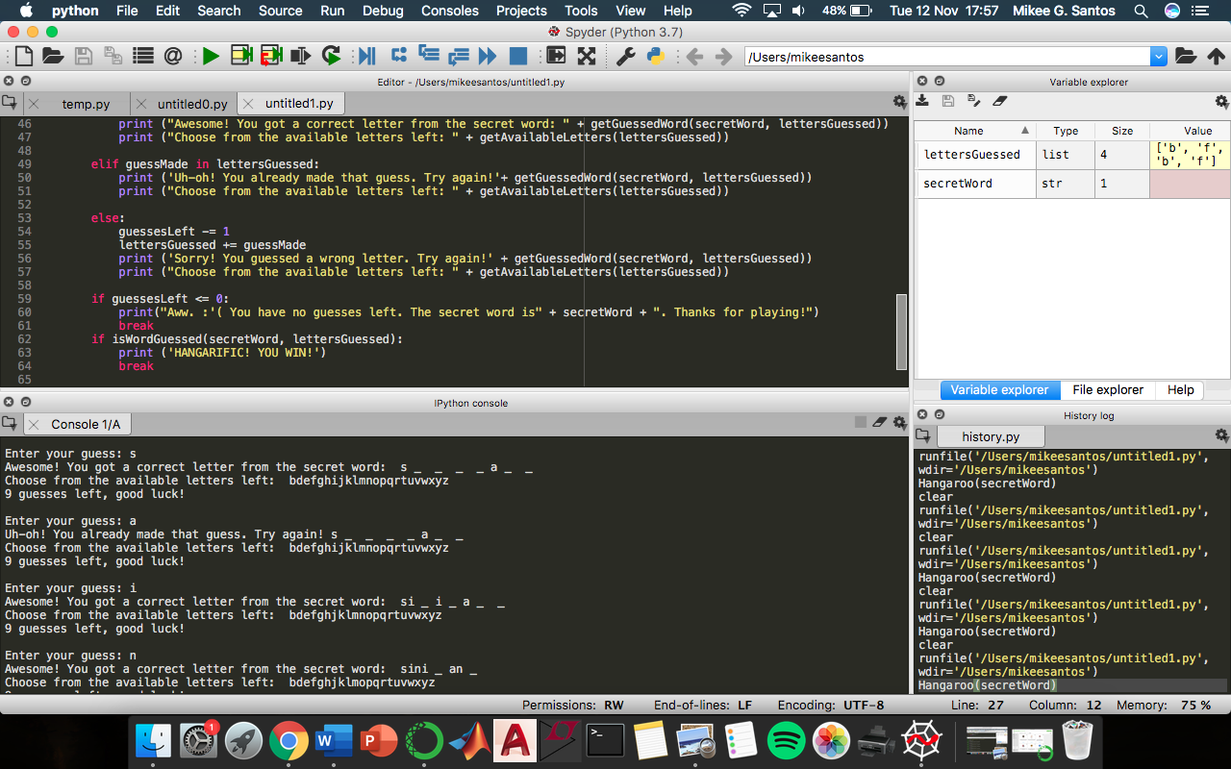

***Problem 4: Hangaroo – Winner (2)***

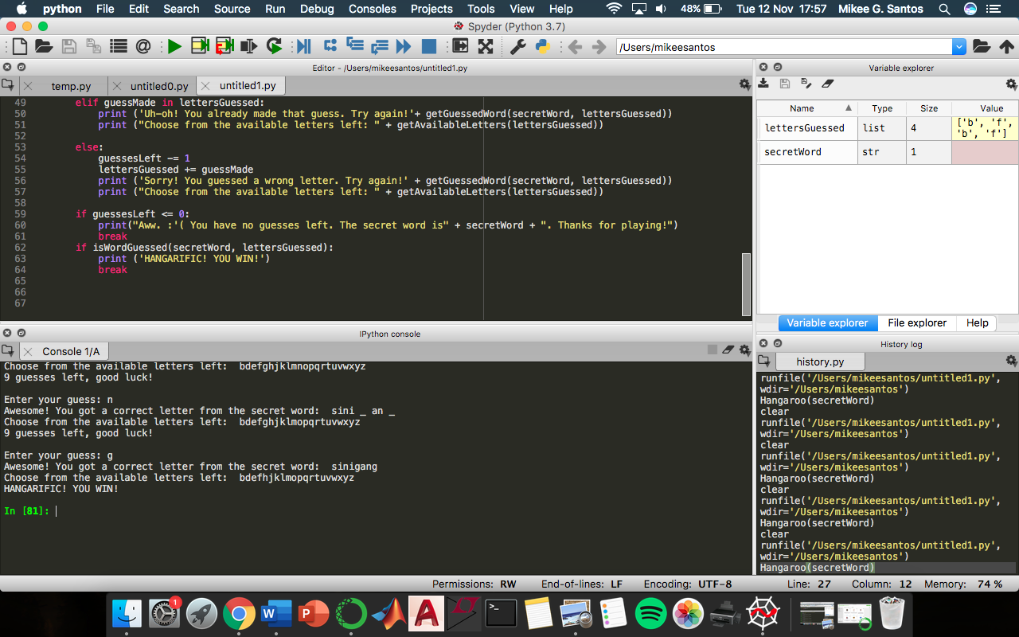

***Problem 4: Hangaroo – Winner (3)***

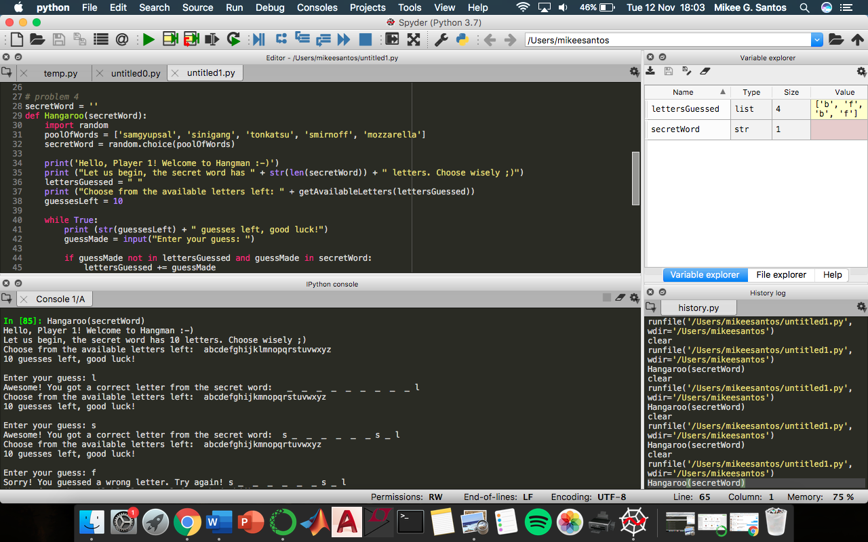

***Problem 4: Hangaroo – Loser (1)***

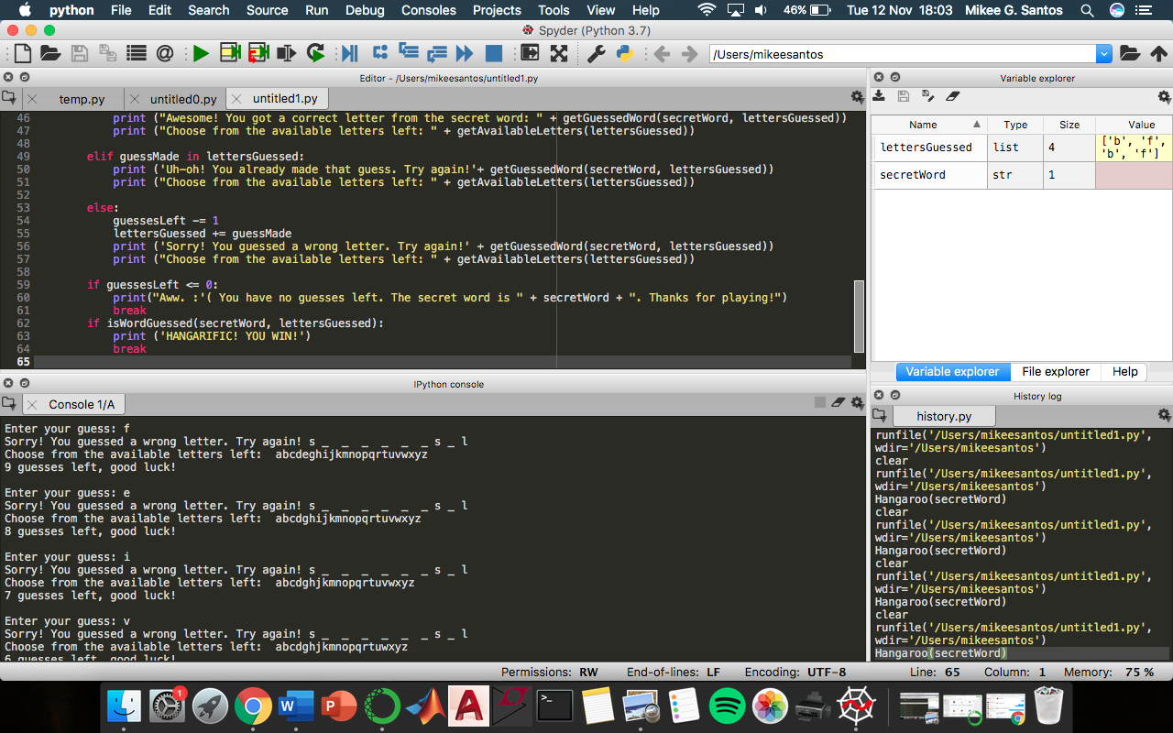

***Problem 4: Hangaroo – Loser (2)***

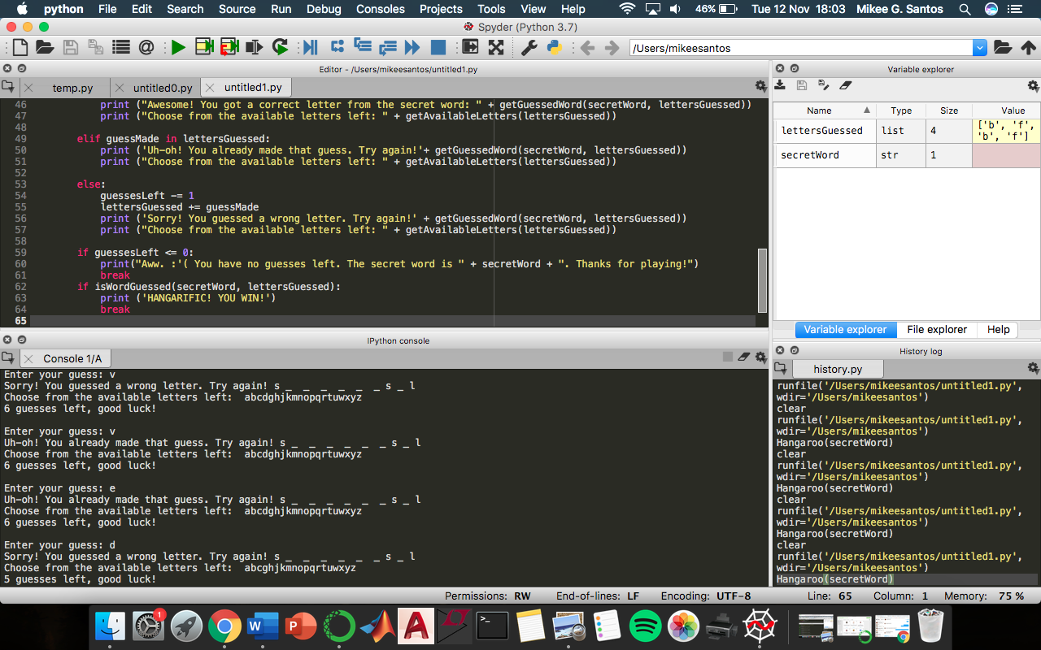

***Problem 4: Hangaroo – Loser (3)***

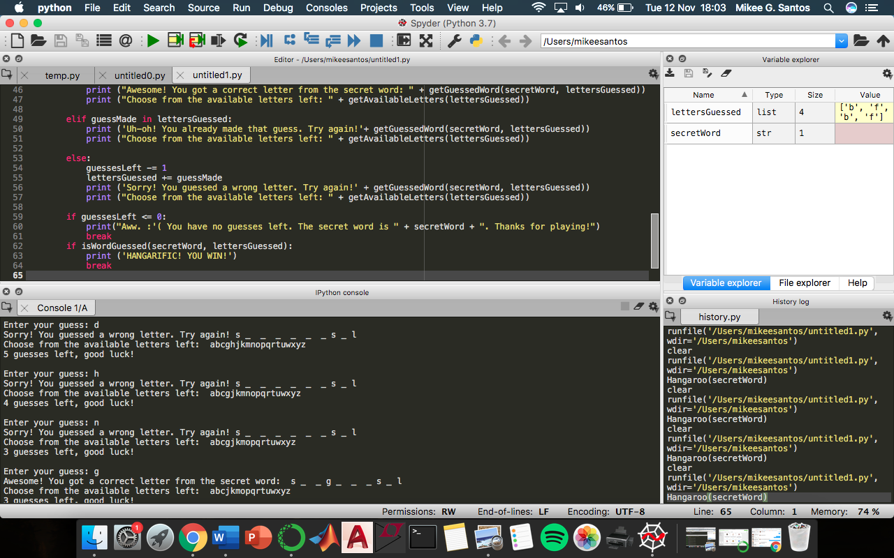

***Problem 4: Hangaroo – Loser (4)***

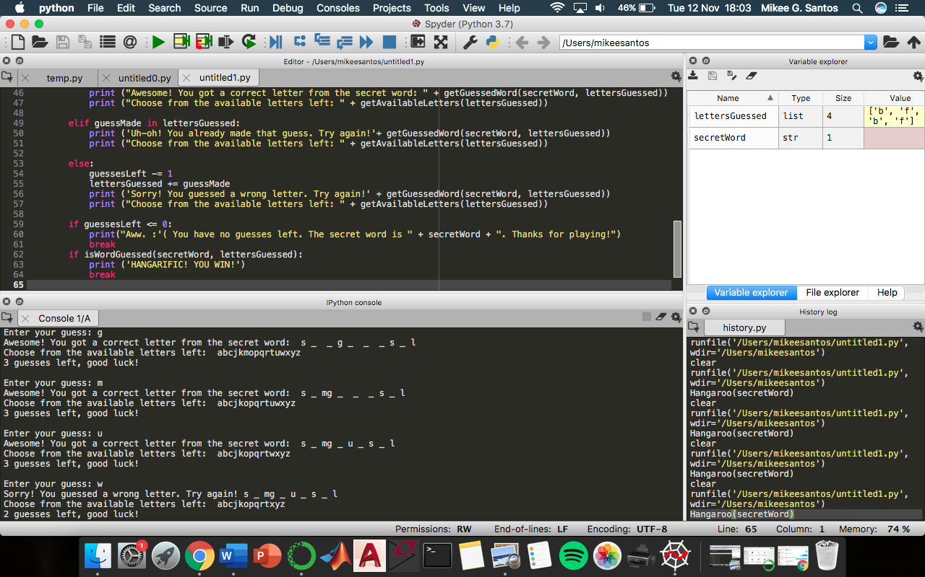

***Problem 4: Hangaroo – Loser (5)***

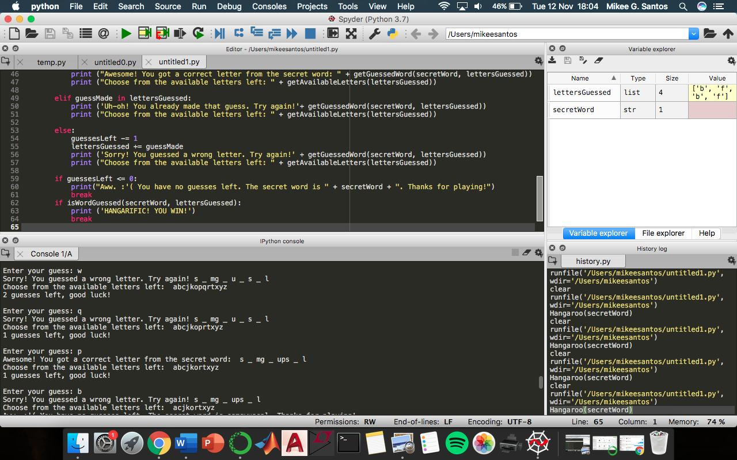

***Problem 4: Hangaroo – Loser (6)***

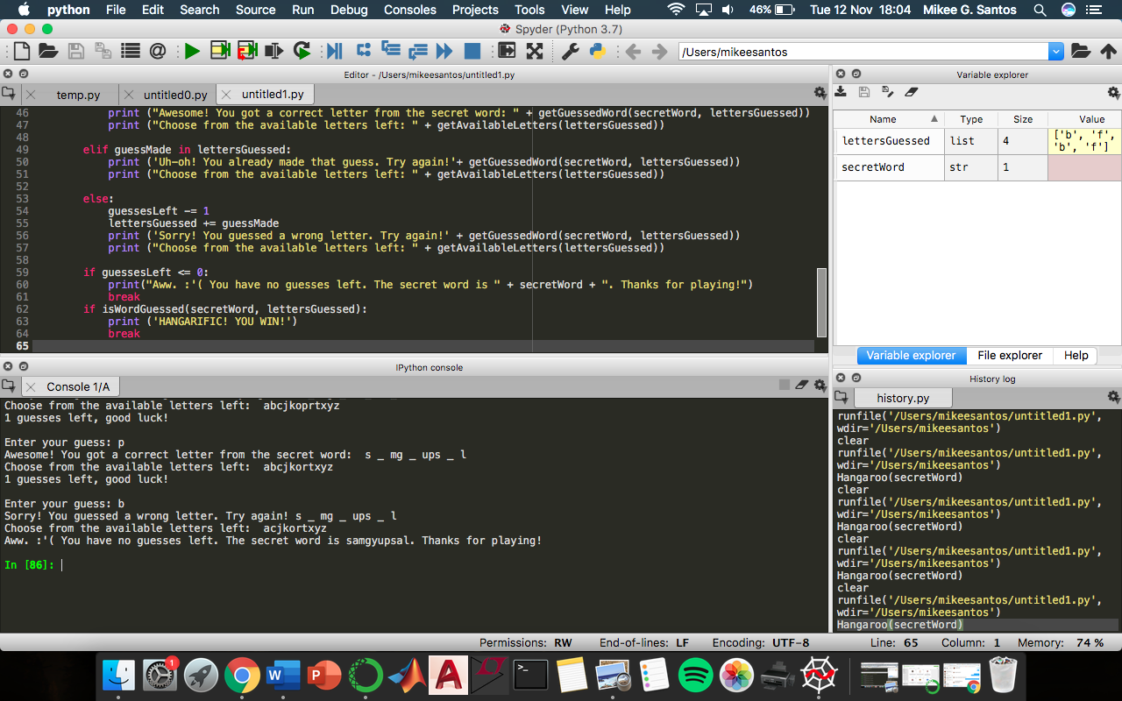

***Problem 4: Hangaroo – Loser (7)***